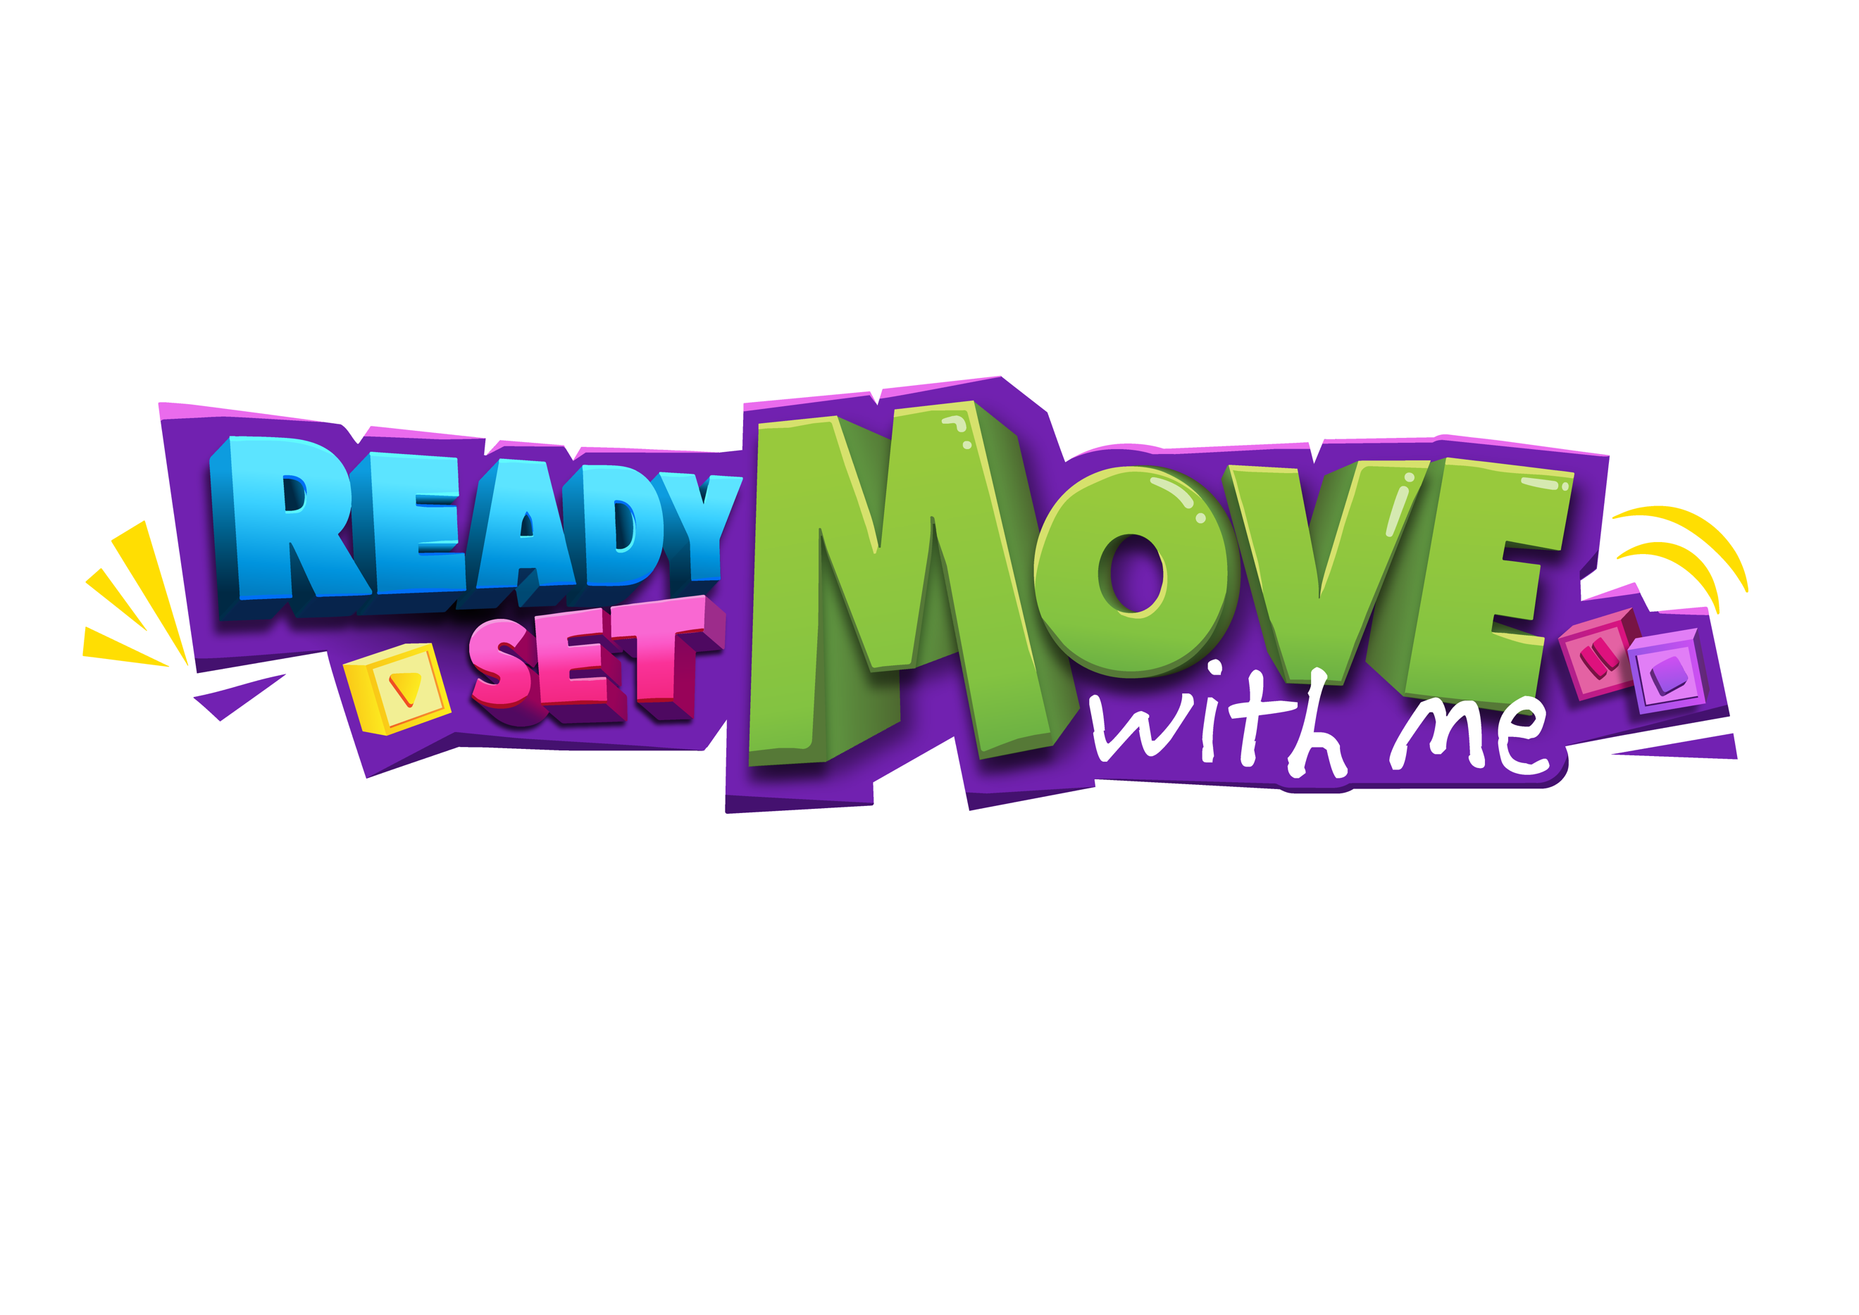
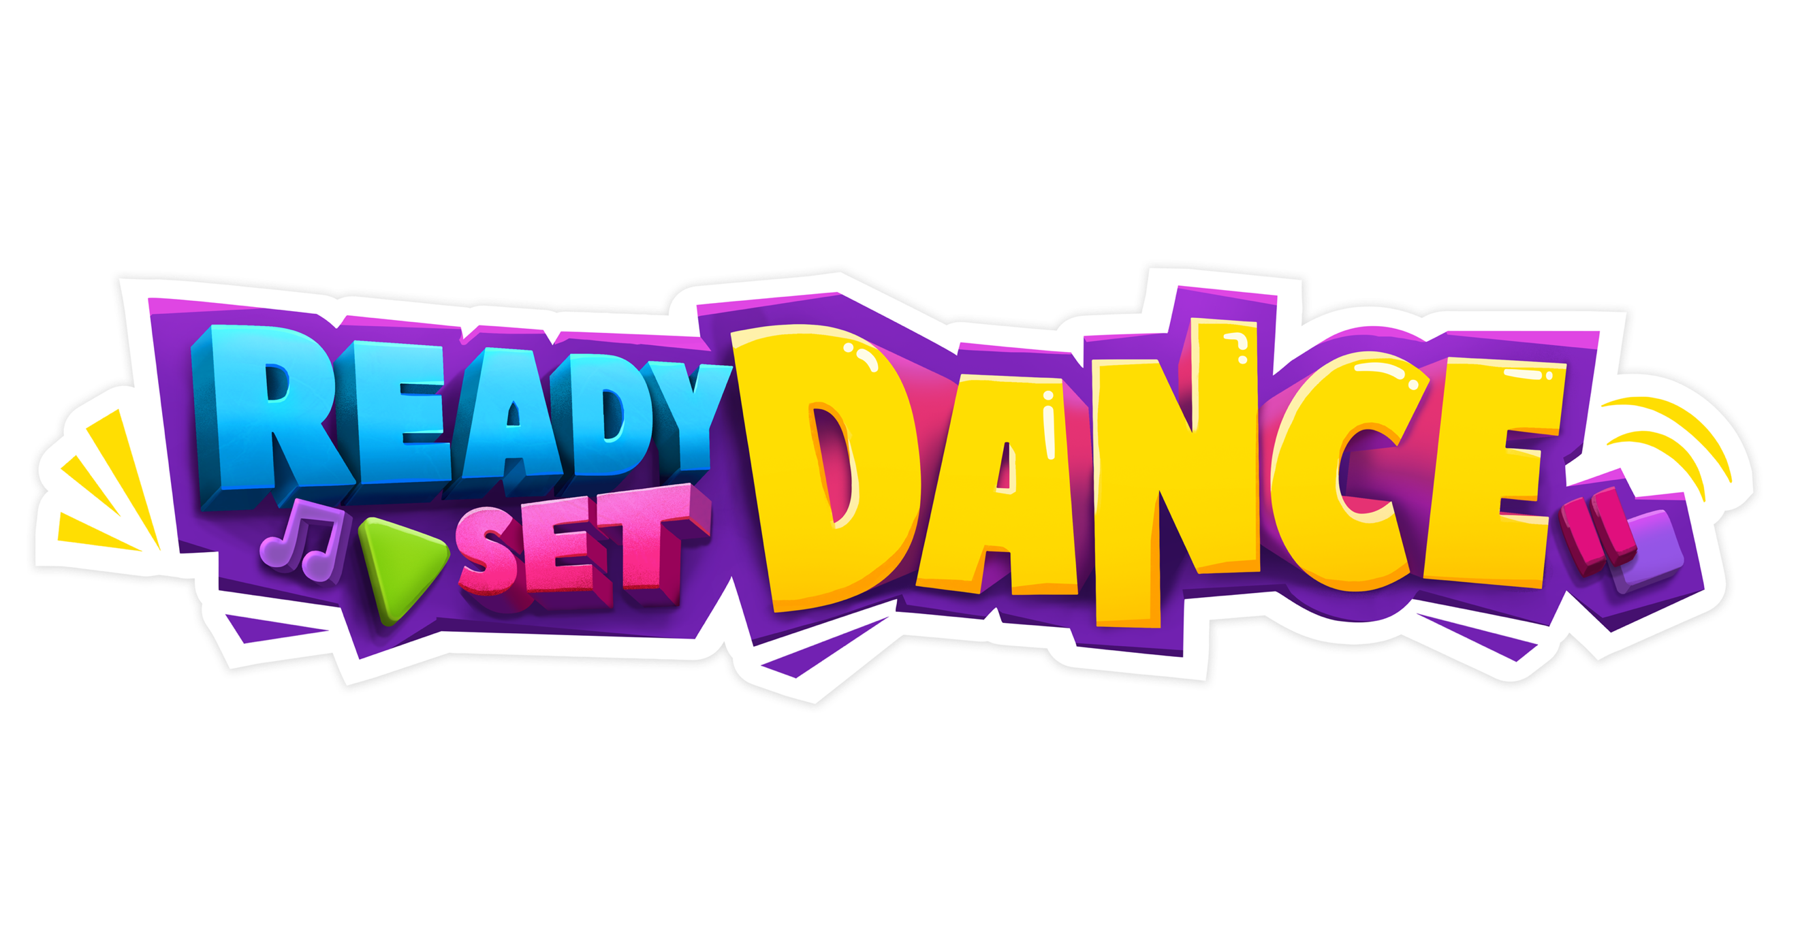
2024 TIMETABLE
MONDAY
TIME | STUDIO ONE | TIME | STUDIO TWO
4:00pm | Tiny Tumble
4:30pm | Stretch & Conditioning | Lyrical
5:00pm | Little Cirque | 5:00pm | Boys Class | Hip Hop | Break Dancing
6:00pm | Dance Cirque
6:30pm | Acrobatics/Acro Dance

TUESDAY [**NOT commencing in Term One]
TIME | STUDIO ONE | TIME | STUDIO TWO
4:30pm | Circus** | 4:30pm | Little Ninja’s** [3-4yrs]
6:30pm | Circus** | 5:30pm | Mini Ninja’s** [5-7yrs]

WEDNESDAY
TIME | STUDIO ONE | TIME | STUDIO TWO
4:00pm | Petites Combo: Ballet I Lyrical I Tap I Jazz | 4:00pm | Cecchetti Ballet
5:00pm | Petites Acro | 5:00pm | Hip Hop
5:30pm | Tap | Street Tap
6:00pm | Musical Theatre [Dance | Sing | Act]
7:30pm | Musical Theatre [Theatrical Jazz]

THURSDAY – Kalkallo North Studio
TIME | STUDIO ONE |  | TIME |  | STUDIO TWO
4:00pm | Ready Set Dance
5:00pm | Petites Combo [Dance | Acro]
6:00pm | Juniors Combo [Dance | Acro]
7:00pm | Musical Theatre [Dance | Sing | Act]
 |  | FRIDAY
TIME | STUDIO ONE | TIME |  | STUDIO TWO
9:30am | Ready Set Move [Toddlers with Adult] **
10:30am | Ready-Set Dance [Pre-School]

SATURDAY
TIME | STUDIO ONE | TIME | STUDIO TWO
9:00am | Mini’s Combo Dance & Mini Acro [4-5yrs]
9:30am | Ready-Set Dance – Level Two | 9:30am | Ready Set Dance – Level One
10:30am | Ready Set Move [Toddlers with Adult]

READY SET MOVE: TODDLERS WITH ADULT PETITE’S: GRADE 2-4 [6-8yrs]
READY SET DANCE: PRESCHOOL [2-5yrs] JUNIORS: GRADE 4-5 [8-10yrs]
TINY’S: KINDER–GRADE 1 [4-5yrs] INTERS: 10yrs+

- TIMETABLE SUBJECT TO CHANGE
- ** CLASSES COMING SOON

